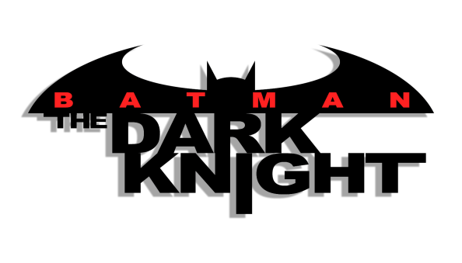
Batman: The Dark Knight [Volume 1]

Issues: 5 [Ongoing series]
Date: January - October 2011

Collected edition:

- Batman: The Dark Knight: Golden Dawn (#1-5).

Batman: The Dark Knight [Volume 2]

Issues: 29 [Ongoing series]
Date: November 2011 - May 2014

This run also includes:

- #0 (2012);
- #23.1-23.4 (2013);
- 1 Annual (2013).

Collected editions:

- Vol. 1: Knight Terrors (#1-8);
- Batman: Night Of The Owls (#9);
- Vol. 2: Cycle of Violence (#10-15, #0);
- DC Comics The New 52 Villains Omnibus (#23.1-23.4);
- Batgirl: Wanted (#23.1);
- Vol. 3: Mad (#16-21);
- Vol. 4: Clay (#22-29);
- Catwoman: Gotham Underground (#23.4).

