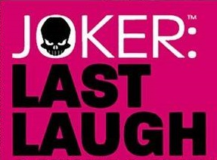
BATMAN: THE JOKER’S LAST LAUGH [2001-2002]
CORE STORYLINE
- Joker: Last Laugh Secret Files and Origins #1
- Joker: Last Laugh #1
- Joker: Last Laugh #2
- Joker: Last Laugh #3
- Joker: Last Laugh #4
- Joker: Last Laugh #5
- Joker: Last Laugh #6
TIE-INS
- Action Comics #784
- Adventures Of Superman #597
- Azrael: Agent Of The Bat #83
- Batgirl (Vol. 1) #21
- Batman #596
- Batman: Gotham Knights #22
- Birds Of Prey (Vol. 1) #36
- Detective Comics #763
- Flash (Vol. 2) #179
- Green Lantern (Vol. 3) #143
- Harley Quinn #13
- Impulse #79
- JLA #59
- JSA #29
- Nightwing (Vol. 2) #62
- Orion #19
- Robin (Vol. 4) #95
- Spectre (Vol. 4) #10
- Superboy (Vol. 4) #93
- Supergirl (Vol. 4) #63
- Superman (Vol. 2) #175
- Superman: Man Of Steel #119
- Titans #34
- Wonder Woman (Vol. 2) #175
- Young Justice #38

