Issues: 74 [Ongoing series]
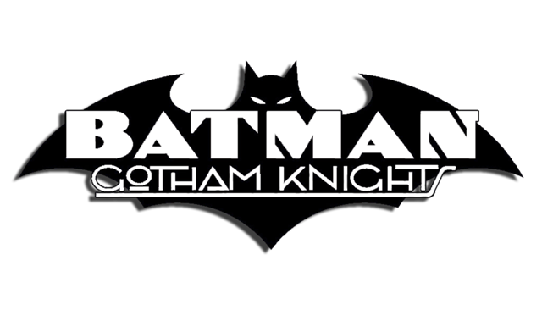
Date: March 2000 - April 2006

1 |  | Constants
2 |  | Down With The Ship
3 |  | Samsara, Part One of Two: Bad Karma
4 |  | Samsara, Part Two of Two: Letting Go
5 |  | Locked
6 |  | Personal Effects
7 |  | Oblation
8 |  | Transference, Part 1 of Four
9 |  | Transference, Part 2 of Four
10 |  | Transference, Part 3 of Four
11 |  | Transference, Part 4 of Four
12 |  | Damages
13 |  | Officer Down, Part Seven: The End (Collected in Batman: Officer Down)
14 |  | Sibling Rivalry
15 |  | Far From the Tree
16 |  | Matatoa, Part 1 of 2
17 |  | Matatoa, Part 2 of 2
18 |  | Cavernous
19 |  | The Factor of Fear!
20 |  | Retribution, Part 1 of 2: Sons and Lovers
21 |  | Retribution, Part 2 of 2: Contested
22 |  | Joker: Last Laugh: Bugged Out
23 |  | Fear of Success  - Collected in Batman: Scarecrow Tales
24 |  | The Devil You Know
25 |  | Bruce Wayne: Murderer?, Part Four: No Exit  - Collected in Batman: Bruce Wayne: Murderer? [OLD & NEW edition]
26 |  | Bruce Wayne: Murderer?, Part Ten: Innocent Until  - Collected in Batman: Bruce Wayne: Murderer?) [OLD & NEW edition]
27 |  | Murderer? Positive I.D.  - Collected in Batman: Bruce Wayne: Fugitive, Vol. 1) [OLD edition]  - Batman: Bruce Wayne: Murderer? [NEW edition]
28 |  | Bruce Wayne: Fugitive, Part Seven: The Mortician, Part 1: Anti-Hero  - Collected in Batman: Bruce Wayne: Fugitive, Vol. 1) [OLD edition]  - Batman: Bruce Wayne: Murderer? [NEW edition]
29 |  | The Mortician, Part 2: Zombie Zero  - Collected in Batman: Bruce Wayne: Fugitive) [NEW edition]
30 |  | Bruce Wayne: Fugitive, Part Fourteen: Turnabout, Part 1 of 2  - Collected in Batman: Bruce Wayne: Fugitive) [NEW edition]
31 |  | Bruce Wayne: Fugitive, Part Seventeen: Clean  - Collected in Batman: Bruce Wayne: Fugitive, Vol. 2 [OLD edition]  - Batman: Bruce Wayne: Fugitive [NEW edition]
32 |  | 24/7  - Collected in Batman: Bruce Wayne: Fugitive) [NEW edition]
33 |  | Tabula Rasa, Prologue: The Devil You Know
34 |  | Tabula Rasa, Part One: Skin Trade
35 |  | Tabula Rasa, Part Two: Pain and Ink
36 |  | Tabula Rasa, Part Three: Pix
37 |  | Spoiler Space
38 |  | Knight Moves, Part 1: The Queen is Dead
39 |  | Knight Moves, Part 2: Castling
40 |  | Knight Moves, Part 3: Checkmate
41 |  | Rubber Soul
42 |  | 20 Days Less One
43 |  | Knights Passed, Part One: Batgirl & Robin
44 |  | Knights Passed, Part Two: Body of Evidence
45 |  | Knights Passed, Part Three: Fathers and Sons
46 |  | Scared Straight
47 |  | Veritas Liberat, Chapter One of Three: King of the Mountain
48 |  | Veritas Liberat, Chapter Two of Three: Family Reunion
49 |  | Veritas Liberat, Chapter Three of Three: The Redeemer
50 |  | Pushback, Book One  - Collected in Batman: Hush Returns
51 |  | Pushback, Book Two  - Collected in Batman: Hush Returns
52 |  | Pushback, Book Three  - Collected in Batman: Hush Returns
53 |  | Pushback, Book Four  - Collected in Batman: Hush Returns
54 |  | Pushback, Book Five  - Collected in Batman: Hush Returns
55 |  | Pushback, Book Six  - Collected in Batman: Hush Returns
56 |  | War Games, Act 1, Part 4 of 8: Rules of Engagement  - Collected in Batman: War Games, Vol. 1: Outbreak  - Collected in Batman: War Games, Vol. 1 [NEW EDITION]
57 |  | War Games, Act 2, Part 4 of 8: The Light at the End of the Tunnel  - Collected in Batman: War Games, Vol. 2: Tides
58 |  | War Games, Act 3, Part 5 of 8: Flight Risk  - Collected in Batman: War Games, Vol. 3: Endgame
59 |  | Fire & Ice
60 |  | The Games People Play
61 |  | Human Nature, Book One
62 |  | Human Nature, Book Two
63 |  | Human Nature, Book Three
64 |  | Human Nature, Book Four
65 |  | Human Nature, Book Five
66 |  | Job Termination  - Collected in Batman: Hush Returns
67 |  | The Life of Riley
68 |  | The Shape of Things to Come, Part One
69 |  | The Shape of Things to Come, Part Two
70 |  | The Shape of Things to Come, Part Three
71 |  | The Shape of Things to Come, Part Four
72 |  | The Letter
73 |  | Payback
74 |  | Payback, Part 2  Batman: Black & White  Batman: Gotham Knights also featured the "Batman: Black & White" back-up strip (from #1-49), which allowed various artists with widely varying styles to do their take on Batman in black and white, 8-page stories.  All "Batman: Black & White" stories have been collected:  - Batman: Black & White, Vol. 1  - Collects the initial 4-issue limited series (1996).  - Batman: Black & White, Vol. 2  - Collects the backup stories from Batman: Gotham Knights #1-16 (+ 5 all-new stories).  - Batman: Black & White, Vol. 3  - Collects the backup stories from Batman: Gotham Knights #17-49.  - Batman: Black & White, Vol. 4  - Collects all-new stories from the 6-issue limited series (2013-2014).

