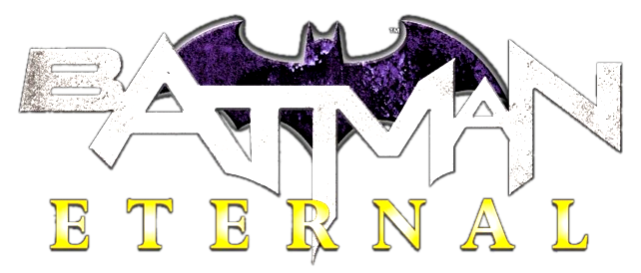
Batman: Eternal

Issues: 52
Date: June 2014 - June 2015

Collected editions:

- Batman: Eternal, Volume 1 (#1-21);
- Batman: Eternal, Volume 2 (#22-34);
- Batman: Eternal, Volume 3 (35-52 + Batman #28).

