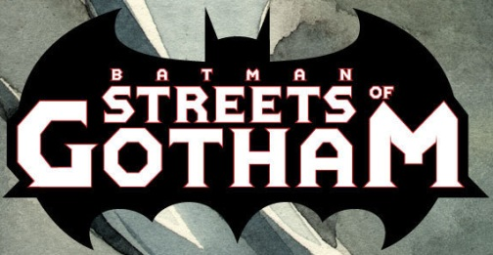

Issues: 21 [Ongoing series]
Date: August 2009 - May 2011

Second features:

- Manhunter ( #1-13);
- Two-Face ( #14, #16);
- Ragman ( #17-18).

Collected editions:

- Batman: Streets Of Gotham: Hush Money (#1-4 );
- Also includes Detective Comics #852 & Batman #685).
- Batman: Streets Of Gotham: Leviathan (#5-11);
- Batman: Streets Of Gotham: House Of Hush (#12-14, #16-21).

NOTE:
- #15 has not been collected.

