BATMAN: JOKERS ASYLUM
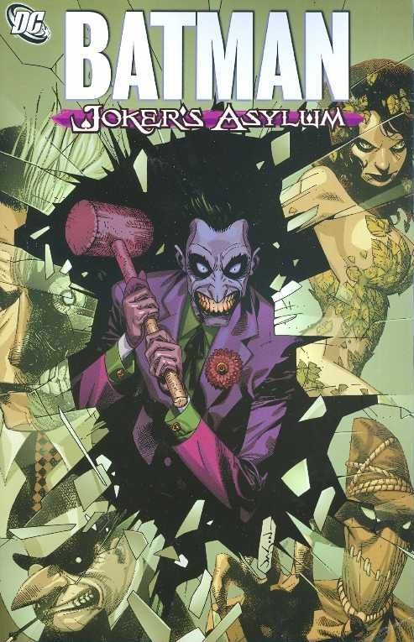
All issues have been collected in 2 trade paperbacks:

Batman: Joker’s Asylum (Book One):

- Joker's Asylum: The Joker
- Joker's Asylum: Penguin
- Joker's Asylum: Two-Face
- Joker's Asylum: Scarecrow
- Joker's Asylum: Poison Ivy

Batman: Joker’s Asylum (Book Two):

- Joker's Asylum: The Riddler
- Joker's Asylum: Harley Quinn
- Joker's Asylum: Clayface
- Joker's Asylum: Killer Croc
- Joker's Asylum: Mad Hatter

