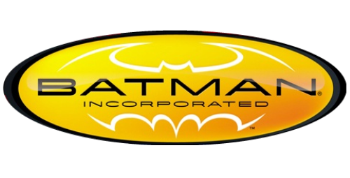

Batman: Incorporated [Volume 1]

Issues: 8
Date: January - October 2011

This series was set to end it's first "season" at issue #10 in August 2011, but due to numerous delays, issues #9 and #10 were unable to be released prior to the September relaunch of the DC Universe (The New 52). Instead, the two issues were published in December as an oversized one-shot titled:

- Batman Incorporated: Leviathan Strikes!

Collected edition:

- Batman: Incorporated (#1-8, Batman: Incorporated: Leviathan Strikes!).

Batman: Incorporated [Volume 2]

Issues: 13
Date: July 2012 - September 2013

This run includes:

- #0 (2012);
- Batman Incorporated Special #1 (2013).

Collected editions:

- Batman: Incorporated, Vol. 1: Demon Star (#0-6);
- Batman: Incorporated, Vol. 2: Gotham's Most Wanted (#7-13, Special #1).

NOTE: Batman: Incorporated Vol. 1-2 have been collected in:

- Absolute Batman: Incorporated.

