<< THE NEW 52 >>
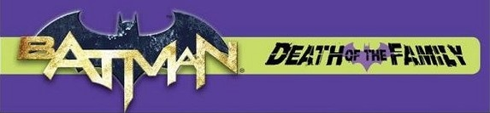
BATMAN: DEATH OF THE FAMILY [2012-2013]
Prelude
000a Detective Comics #1
000b Suicide Squad #6
000c Suicide Squad #7
001 Batgirl #13
002 Catwoman #13
003 Catwoman #14
Chapter 1: The Joker Is Back
004 Batman #13
005 Batman & Robin #13
006 Batman & Robin #14
007 Suicide Squad #14
008 Suicide Squad #15
Chapter 2: The Jokes On You
009 Batman #14
010 Detective Comics #15
011 Batgirl #14
012 Batgirl #15
013 Batgirl #16
014 Batman #15
015 Batman & Robin #15
016 Batman & Robin #16
017 Detective Comics #16
*Detective Comics #17 (Recommended)
018 Nightwing #15
019 Nightwing #16
020 Red Hood & The Outlaws #15
021 Teen Titans #15
022 Red Hood & The Outlaws #16
023 Teen Titans #16
024 Batman #16
025 Batman #17
Epilogue
026 Red Hood & The Outlaws #17
027 Red Hood & The Outlaws #18

