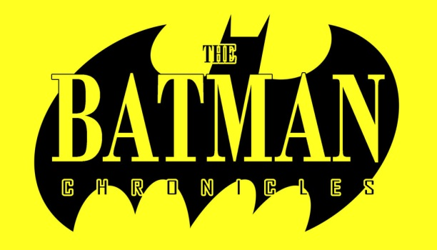
Issues: 23
Date: July 1995 - November 2001

• Most issues contain 3 (separate) stories.
• This run also includes The Batman Chronicles Gallery #1 (1997).

Batman Chronicles #1 (summer 1995): "Midnight Train"
Batman Chronicles #1/2 (summer 1995): "Anarky: Tomorrow Belongs to Us"
Batman Chronicles #1/3 (summer 1995): "Death Mask"

(#1/2 ‘’Anarky: Tomorrow Belongs To Us’’ has been collected in ‘’Batman: Anarky’’)
Batman Chronicles #2 (fall 1995): "The Space Between Good and Evil"
Batman Chronicles #2/2 (fall 1995): "Goin' Downtown"
Batman Chronicles #2/3 (fall 1995): "Commissions"

Batman Chronicles #3 (winter 1996): "Riddle of the Jinxed Sphinx"
Batman Chronicles #3/2 (winter 1996): "The First Cut Is the Deepest"
Batman Chronicles #3/3 (winter 1996): "Workin' My Way Back To You"
Batman Chronicles #4 (spring 1996): "Hitman"
Batman Chronicles #4/2 (spring 1996): "Huntress: Exposure"
Batman Chronicles #4/3 (spring 1996): "Beggar's Banquet"

(#4/3 ‘’Beggar’s Banquet’’ has been collected in ‘’Batman: Contagion’’)
Batman Chronicles #5 (summer 1996): "Oracle: Year One"
Batman Chronicles #5/2 (summer 1996): "Decoys"
Batman Chronicles #5/3 (summer 1996): "Of Mice and Men"
Batman Chronicles #6 (fall 1996): "Choices"
Batman Chronicles #6/2 (fall 1996): "Shadow Job"
Batman Chronicles #6/3 (fall 1996): "Citiscape"

Batman Chronicles #7 (winter 1997): "World's Finest: Equal Justice"
Batman Chronicles #7/2 (winter 1997): "Like Riding a Bicycle"
Batman Chronicles #7/3 (winter 1997): "Double Play"

Batman Chronicles #8 (spring 1997): "The Prison"
Batman Chronicles #8/2 (spring 1997): "Double Jeopardy"
Batman Chronicles #8/3 (spring 1997): "Secrets of the Batcave: Dinosaur Island"

Batman Chronicles #9 (summer 1997): "Photo Finish"
Batman Chronicles #9/2 (summer 1997): "Just Desserts"
Batman Chronicles #9/3 (summer 1997): "Passion's Fruit"

(#9 ‘’Photo Finish’’ has been collected in ‘’Batgirl: The Greatest Stories Ever Told’’)

Batman Chronicles #10 (fall 1997): "To See the Batman"
Batman Chronicles #10/2 (fall 1997): "The Madman's Tale"
Batman Chronicles #10/3 (fall 1997): "Odd Attachment"
Batman Chronicles #11 (winter 1998): "Berlin Batman"
Batman Chronicles #11/2 (winter 1998): "The Bride of Leatherwing"
Batman Chronicles #11/3 (winter 1998): "Curse of the Cat-Woman"

(#11 ‘’Berlin Batman’’ has been collected in ‘’Batman: Year 100’’)
Batman Chronicles #12 (spring 1998): "The Contract"
Batman Chronicles #12/2 (spring 1998): "House of Cards"
Batman Chronicles #12/3 (spring 1998): ""

(All 3 stories of #12 have been collected in ‘’Batman: Cataclysm’’)
Batman Chronicles #13 (summer 1998): "Duty, Trust, Partnership"
Batman Chronicles #13/2 (summer 1998): "Friends, Lies, and Audiotape"
Batman Chronicles #13/3 (summer 1998): "Partners"
Batman Chronicles #14 (fall 1998): "Master of the House"
Batman Chronicles #14/2 (fall 1998): "The Lunatic Fringe"
Batman Chronicles #14/3 (fall 1998): "Random Encounters"

(All 3 stories of #14 have been collected in ‘’Batman: The Road To No Man’s Land, Vol. 1’’)
Batman Chronicles #15 (winter 1999): "Will to Power"
Batman Chronicles #15/2 (winter 1999): "Between Stars Above and Below"
Batman Chronicles #15/3 (winter 1999): "An Answer in the Rubble"
Batman Chronicles #16 (spring 1999): "Two Down"
Batman Chronicles #16/2 (spring 1999): "The Comforts"
Batman Chronicles #16/3 (spring 1999): "Harold"

(#16 has been collected in ‘’Batman: No Man’s Land’’ Vol. 2 OLD/Vol. 1 NEW)

Batman Chronicles #17 (summer 1999): "Little Boy Lost"
Batman Chronicles #17/2 (summer 1999): "Turn On, Tune In, Freak Out"
Batman Chronicles #17/3 (summer 1999): "Identity Crisis"

(All 3 stories of #17 have been collected in ‘’Batman: No Man’s Land’’ Vol. 2 (NEW EDITION)

Batman Chronicles #18 (fall 1999): "Spiritual Currency"

(#18 has been collected in ‘’Batman: No Man’s Land’’ Vol. 4 OLD EDITION/Vol. 4 NEW EDITION)

Batman Chronicles #19 (winter 2000): "Got a Date with an Angel"
Batman Chronicles #19/2 (winter 2000): "Rapscallions"
Batman Chronicles #19/3 (winter 2000): "The Penny Plunderers"
Batman Chronicles #20 (spring 2000): "Whipersnappers of Mass Destruction"
Batman Chronicles #20/2 (spring 2000): "Photo Finish"
Batman Chronicles #20/3 (spring 2000): "The Rage of Angels"

Batman Chronicles #21 (summer 2000): "Apocalypse Girl"
Batman Chronicles #21/2 (summer 2000): "Citizen Wayne"
Batman Chronicles #21/3 (summer 2000): "A New Batman is Born"
Batman Chronicles #22 (fall 2000): "Pay the Ferryman"
Batman Chronicles #22/2 (fall 2000): "Cry, Uncle"
Batman Chronicles #22/3 (fall 2000): "Daughter of the Demon"
Batman Chronicles #23 (winter 2001): "The Bomb, The Bull, The Butler & The Bat"
Batman Chronicles #23/2 (winter 2001): "Automotive"
Batman Chronicles #23/3 (winter 2001): "The Mimic"

